

Practical Report

For IoT Practical



January 1, 2022

Darshan Ramjiyani (DSP)

DOCS, KSKV Kachchh University

* **4.6 Serial Communication – Sending binary data from Arduino.**
* **Arduino Code:**

int intValue;

int baudRate = 9600;

void setup()

{

  pinMode(LEDPin, OUTPUT);

  /* Established Serial Communication. */

  Serial.begin(baudRate);

  Serial.println("Connection Establishing connection...!");

  while(!Serial){}

  Serial.println("Connection Established!");

  /* Wait until Serial Communication not established. */

  while(!Serial){}

  /* Send data through Serial Communication. */

  Serial.println("- Name of Author : DSP -");

  Serial.println("---------------------------------------------------------");

}

void loop()

{

   Serial.print('H');

   intValue = random(599);

   Serial.write(lowByte(intValue));

   Serial.write(highByte(intValue));

   intValue = random(599);

   Serial.write(lowByte(intValue));

   Serial.write(highByte(intValue));

   delay(1000);

}

* **4.7 Serial Communication – Receiving binary data from Arduino**

Here, we receive data in python program which we have send in 4.6.

Requires PySerial library.

* + **Python Code:**

import serial

connection = serial.Serial("COM7", 9600)

while True:

    Data : str = connection.read()

    Data = int.from_bytes(bytes(connection.read()), "little")

    print("Recieved Data : ", Data)

    Data += int.from_bytes(bytes(connection.read()), "big")

    print("Recieved Data : ", Data)

* 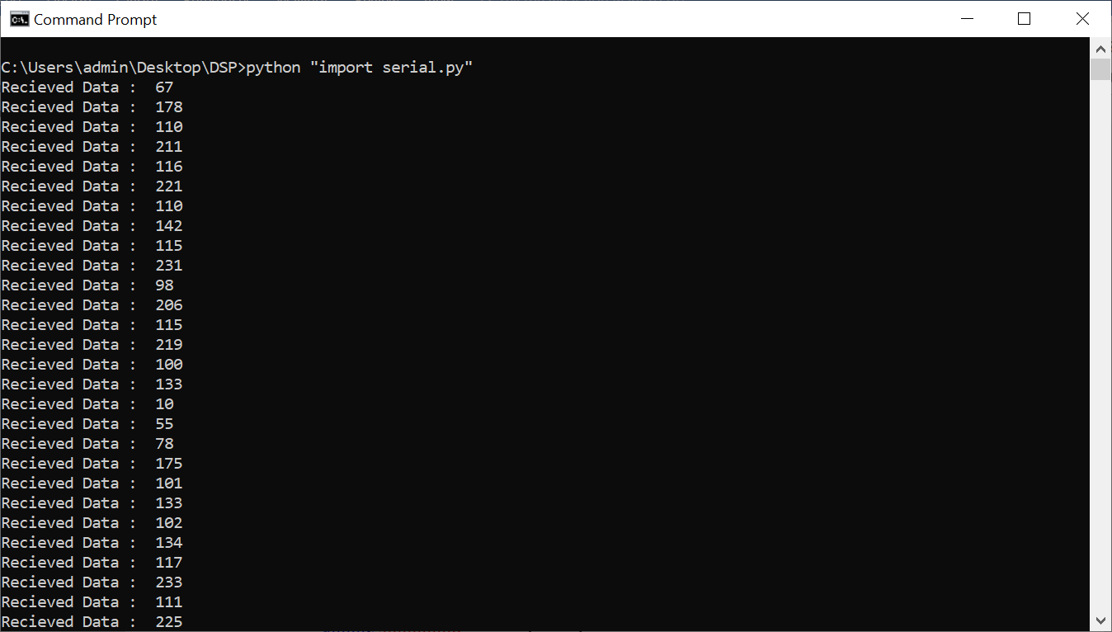Output:

Output From Dwaidh Terminal